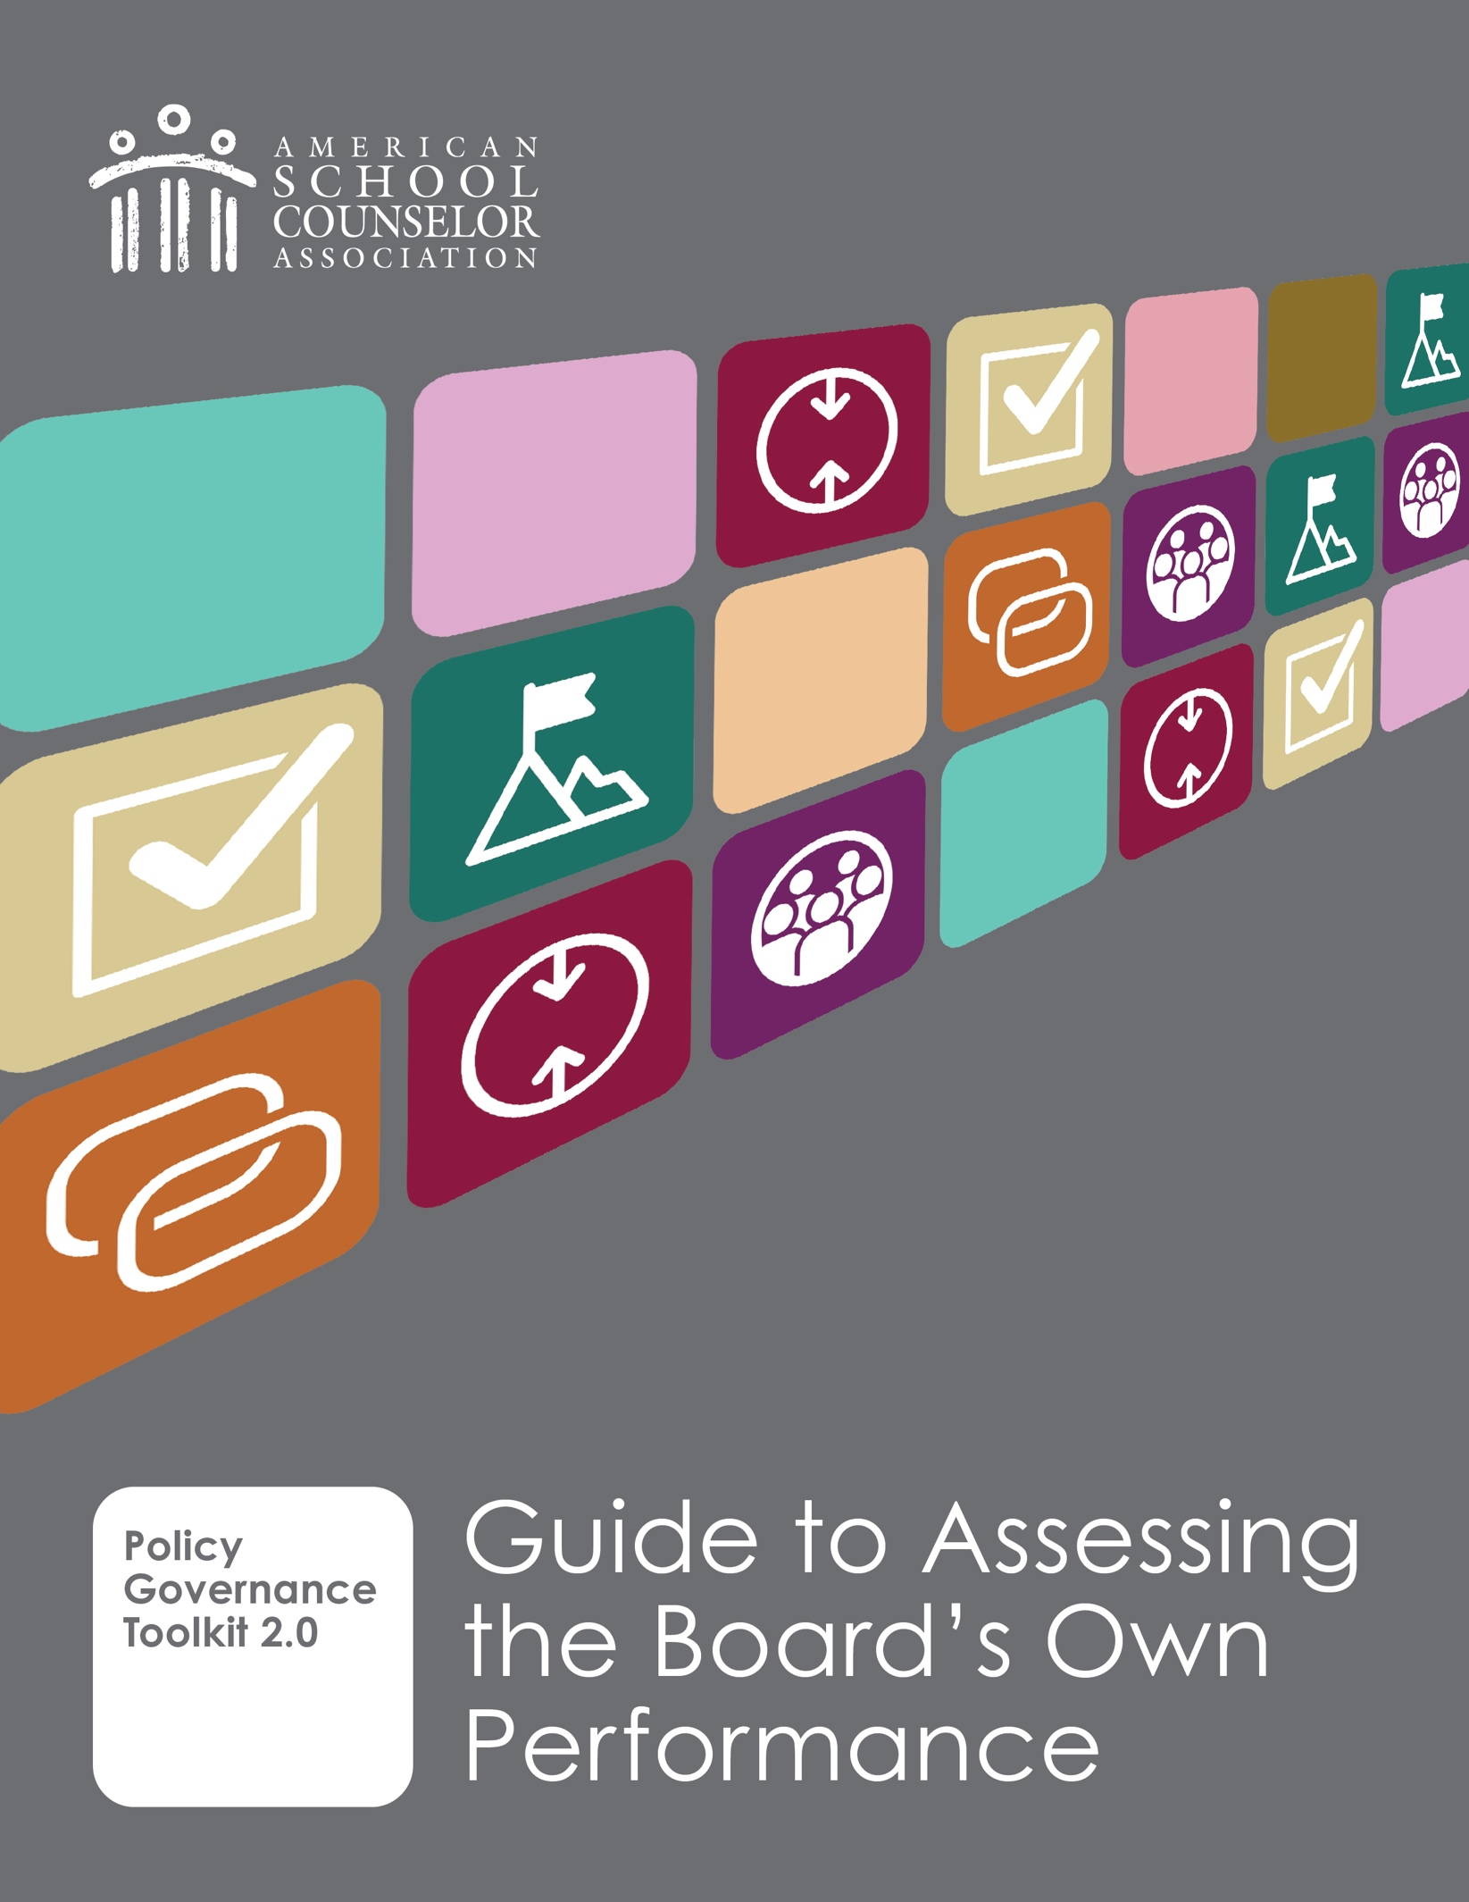

# Is Your Board Governing Well?

Board self-assessment is a core aspect of governing well. Why should your board take time to assess its performance?

* **Monitoring is one of the board’s essential governing responsibilities.**
* **It’s only fair.** If the board is monitoring the executive director’s performance, it should also monitor its own.
* **It keeps the board focused on governance**, not on any operational or administrative tasks it may have retained by choice or necessity.

This tool in the Policy Governance Toolkit provides your board with a useful perspective on the importance of board self-assessment and some practical tools and tips to make the process efficient and effective. The assumption is that boards benefiting from the information in this guide are also using a Policy Governance policy template framework available in the Board Manual document, another tool in ASCA’s Policy Governance Toolkit.

**What if your board isn’t using Policy Governance (yet)?**  
Although this self-assessment method is designed for boards using Policy Governance, **some elements could still be adapted** – especially if your board has adopted any governing values or commitments. However, without a clearly defined governance framework, assessing performance is less effective – and may be more prone to personality conflicts.

Let’s get started.

How Should the Board Approach Assessing Its Performance?

Use the same spirit and logic you apply when monitoring the executive director:

* Be **systematic** but **efficient**.
* **Focus** on your **own Governance Process and Board-Management Delegation policies**.
* Make it a **learning tool**, not a blame session.

## Two Approaches to Board Self-Monitoring

We provide two approaches to self-monitoring, either once annually or on-going. Either approach is fine when done with integrity. Let’s look at each approach.

### Annual Review Approach

#### **Purpose**

A comprehensive view of the board’s performance to be completed once a year.

* **When**: Set aside time once per year, often at an annual board retreat.
* **What:** Review your entire set of Governance Process and Board-Management Delegation policies.
* **How**: Use the following questions to guide discussion:
  + Did we do what we said we’d do?
  + If yes: What worked? What needs improvement?
  + If no: Why not? What needs to change – the policy, our resources or our process?

What are the benefits of this once-a-year approach? It creates time and space for deeper group reflection. If done in conjunction with planning for the upcoming year, this is a seamless way of identifying and scheduling education to improve any identified weaknesses.

**Process**

Think of the *annual review* as the **conversation** – intentional, often reflective and policy-based. This is a **deliberate, structured activity** to assess the board’s compliance with Governance Process and Board-Management Delegation policies. The process would typically include:

* Reviewing each policy (or a selected subset).
* Reflecting on whether the board behaved in alignment with its own standards.
* Identifying strengths, gaps and trends.
* Discussing implications for training, policy revision or changes in process.

#### **Tips**

* Use the annual summary (more about that below) to plan board development activities to improve your performance, onboarding and policy revisions.
* Celebrate wins to reinforce board culture and accountability.

**Product**

This is the **written or visual artifact we call an annual summary.** The resulting product of this review could include:

* A simple table showing each policy reviewed and whether it was followed.
* A narrative summary of the board’s performance.
* A list of recommended improvements or focus areas for the coming year.
* Documentation of any policy revisions or training decisions.

The annual summary becomes a record of accountability – and a useful tool for reporting to the association’s members, community and other affected parties**.** Why do both products matter?

* **The review** keeps the board honest and self-aware.
* **The summary** makes the board transparent and improves continuity year to year – especially when there’s turnover.

A **template for an annual summary starts on the next page**. Here are some tips for how to use it:

* Copy the Annual Board Performance Summary Template into a separate document. If you want more space, consider setting it up in landscape mode.
* Be sure to align the table contents with your board’s policies and numbering. This form is based on the policy templates found in the Board Manual template.

# Annual Board Performance Summary Template

A document of the board’s self-assessment of Governance Process and Board-Management Delegation policies.

Reporting Year:

Date of annual review discussion:

Facilitated by (if applicable):

## Summary Table of Reviewed Policies

|  |  |  |  |  |
| --- | --- | --- | --- | --- |
| **Policy Area** | **Reviewed?**  **(yes or no)** | **Compliant?**  **(yes, no, partial)** | **Key observations** | **Follow-up actions** |
| 3.0 Board-Management Delegation (Global) |  |  |  |  |
| 3.1 Board Direction to the Executive Director |  |  |  |  |
| 3.2 Monitoring and Executive Director Performance |  |  |  |  |
| 3.3 Monitoring Method and Frequency |  |  |  |  |
| 4.0 Governance Process (Global) |  |  |  |  |
| 4.1 Governing Commitments |  |  |  |  |
| 4.2 Board’s Job Products |  |  |  |  |
| 4.3 Group Responsibilities |  |  |  |  |
| (others your SCA has added?) |  |  |  |  |

Summary reflections

1. What did the board do well this year in its governance role? (*(Brief bullets or 1–2 sentences)*
2. Where did the board experience challenges or inconsistencies?
3. Are any policy changes recommended as a result of this review?  
   ☐ Yes ☐ No  
   *If yes, list policies and rationale:*
4. What governance support or board development activities, should be planned for next year?  
   *(E.g., training, onboarding updates, meeting process improvements)*

#### **Tip**

Having a hard time imagining the types of notes you might make? Here are a few common types of notes to get your thoughts flowing:

* **Compliance Notes**: “Yes, but we need to formalize the process.”
* **Behavioral Observations**: “We drifted into operations on agenda item X.”
* **System Gaps**: “We forgot to update the monitoring schedule after new policies were adopted.”
* **Support Needs**: “Board members unsure how to interpret policy; training needed.”

### Ongoing Monitoring Approach

**Purpose**

Make self-monitoring a habit, manageable and routine. By doing small bites of monitoring at the end of each meeting – just one policy or even part of a policy – the board spreads the work out while keeping governance top of mind and not requiring extra meetings. The approach also makes self-reflection a normal part of regular business. What are the benefits of this approach? It promotes continuous reflection and alignment with the board’s stated values. It also keeps the focus on governance alive and active in board culture.

#### **Process**

* **When**: Last 10-15 minutes of every board meeting.
* **What**: Pick one–three Governance Process or a Board-Management Delegation policies to review.
* **How**:
  + Ask: “Did we comply with this policy in our behavior today?”
  + Note areas of strength and gaps.
  + Track responses to inform the annual review and summary.

#### **Tips**

* Have a schedule of when policies are due to be monitored along with a rotating list of members assigned to pay particular attention to the board behavior or actions as defined in their policy during their assigned meeting.
* Alternatively, make monitoring board compliance with policies part of an officer’s responsibilities. This has the added benefit of helping that officer develop a deeper understanding of those policies, perhaps in preparation for a larger role at a later date.

#### **Product**

The “product” of the ongoing approach is a **cumulative tracking log or dashboard** that visually summarizes self-assessment results over time.

This could take the form of:

* **A color-coded matrix or grid** (e.g., traffic light system: green = consistent compliance, yellow = partial, red = not in alignment) where each row is a Governance Process or Board-Management Delegation policy, and each column represents a board meeting where that policy was monitored.
* **A bar chart or heatmap** showing which policies are being reviewed regularly and how the board is assessing its performance over time.
* **A simple scoring log** where each policy is assigned a 1–3 scale (e.g., 3 = fully aligned,   
  2 = somewhat aligned, 1 = not aligned) with short narrative notes and reviewer initials.

* For boards not using Policy Governance: this tool can also track performance against your written board norms, committee structures and standard procedures. Just replace policy numbers with your own categories (e.g., “Board Chair Duties,” “Decision-Making Norms,” “Meeting Prep”).
* This log becomes a living artifact of the board’s performance and can feed into the annual summary. It builds continuity, shows trends and reinforces the culture of shared accountability.

## Prioritizing Improvements: A Decision Matrix Template

Whether your board uses the annual or ongoing approach to assessing your governing performance, it will have to decide how to deal with performance issues that arise during the assessment process. Boards can quickly triage them using this four-quadrant matrix knowing that not everything needs fixing right away.

|  |  |
| --- | --- |
| **Do now**  (low effort, big win)  Examples:   * Add board training item to next agenda. * Reinforce “speak with one voice” norm with reminder email. * Update monitoring calendar in manual. | **Plan and Commit**  (high effort, big win)  Examples:  Improve onboarding to include governance orientation.  Address recurring confusion about board vs. staff roles. |
| **Low Priority**  (low effort, not urgent)  Examples:   * Reword policy phrasing for clarity. * Create a boardroom “cheat sheet” for meeting procedures. | **Reconsider or Defer**  (high effort, results not certain)  Examples:   * Overhauling policy format without clear need. * Launching a committee to explore minor governance tweaks. |

If using the matrix seems overwhelming, when a policy performance issue or a concerning trend is identified, the group could simply ask itself the following two questions:

1. How much effort will it take to address this?
2. How big of a difference would it make to the board’s performance?

### What About Individual Accountability?

A common concern among boards is: “What if a member isn’t pulling their weight?” Policy Governance addresses this – not by policing individual behavior, but by setting shared values for how the board operates as a group, which inherently includes individual responsibility. Take this policy, for example:

*"The board commits itself to ethical, businesslike and lawful conduct, including adequate individual study and preparation prior to meetings, proper use of authority and appropriate decorum when acting as board members."*

This is **not just about the group; it’s also about each member’s contribution to the group’s success**. During self-assessment, the board can ask:

* Are we, as a board, consistently upholding our approach to governing?
* Are there behaviors that are helping – or hindering – our effectiveness?
* What support or reminders might help us collectively do better?

This approach protects the integrity of the board while reinforcing a culture of accountability, trust and shared commitment.

**Tips:**

* Before discussing the questions listed above, the person leading the discussion might say, “Let’s all take a minute to collect your thoughts by reflecting first on how you have supported our governing approach before thinking more broadly about how we show up together.”
* Keep discussions issue-focused and grounded in policy, not personalities. If consistent issues with an individual arise, the chair can follow up privately, referencing the board’s adopted expectations – not personal opinions.

**That’s it! Now it is time for your board to pick its approach to**

**assessing its performance and get started.**