**[Org. Name] SOCIAL MEDIA STYLE GUIDE**

Last updated on 9/26/24

**Contents**

Voice and Tone 2

Spelling, Grammar, and Punctuation 2

Etiquette & Engagement 2

Formatting 3

Logo 3

Colors 4

Emoji Usage **4**

Hashtag Usage 4

Multimedia Usage 6

Content Summary 6

Facebook 6

X (formerly Twitter) & Bluesky 7

Instagram 8

LinkedIn 9

# Voice and Tone

Think about how you want your organization to sound and represent itself.

**Sample below:**

Our voice is professional and genuine. We speak with clarity and strive for expertise. We act as a source of information for our members, stakeholders, and industry followers, and our voice should reflect that by being open, honest, and straightforward.

Our tone is friendly and positive.

# Spelling, Grammar, and Punctuation

This helps maintain consistent branding and voice. Consider what words are never abbreviated, when and if acronyms are used, and how your organization writes.

**ASCA sample below:**

* Avoid abbreviating beyond standard abbreviations,
  + Standard abbreviations include names of companies/other associations, legislative bills, and widely used abbreviations related to the profession.
  + Unacceptable abbreviations are shortening words like info, tho, and thx.
* Always check your spelling
* Limit exclamation points to one per post, and do not put several in a row.
* Do not use the Oxford comma
* Use relevant emojis sparingly; for more details, see Emoji Usage
* Avoid using “I” unless included as part of a quote

ASCA terms and trademarks:

There are several ASCA-branded items and publications that, for trademark and branding purposes, must always be written as below:

* ASCA National Model
* ASCA Students Standards
* ASCA Ethical Standards

Profession terms:

* Always use “school counselor,” never “guidance counselor,” or plain “counselor.”
* Social/emotional learning (always has the slash when written out)

# Etiquette & Engagement

Consider how and when you respond to comments.

**Sample:**

All vulgar comments should be deleted.

Negative comments generally fall under two categories: customer service-related and politically related.

If the comment is customer service related:

* Respond quickly and politely
* Listen to what the customer has to say; don’t try to make excuses
* Take the conversation offline
  + The initial response should be a public reply
  + Then, ask for them to direct message

How to deal with trolls:

* **Avoid Engaging**. None of these people want to listen or have a conversation. Responding to them only encourages them and gives them the attention they want.
* For all platforms: Hide or delete any comments on your posts. If the commenter persists, you can block them at your discretion.
* For X: On every post, there are three dots in the upper right-hand corner. Clicking the three dots displays the dropdown menu to the right.
  + Levels of escalation:
* "Leave Conversation" will prevent ASCA from being tagged in any replies to the original post, and the hyperlink will be removed from the ASCA handle.
* "Report post" will flag the post for review to have it taken down.
* "Block" will prevent the person from viewing your profile; however, they will still be able to mention you in future posts.

# Formatting

* Concise captions; 1-3 sentences
* Links should be shortened whenever possible

# Logo

It’s important consistent branding to consider how your logo is used in terms of when it’s used, what colors it can be in, proportions, and how much of it is used (i.e. icon usage vs the full logo).

Sample:

* Logo proportions should remain the same.
* The ASCA logo can be black, white or black letters with khaki “people.”
* The ASCA logo can appear with only the “people” icon.

# Colors

These are the primary ASCA colors:

* Khaki Gold: #D4BD87
* Green: #319A86
* Blue: #13396B
* Pink: #D41B55
* White: #FFFFFF
* Black: #2A252C

# Emoji Usage

When and how we use emojis:

* Emojis should be used sparingly
* Emoji use is encouraged if a commenter uses them
* Do not place emojis in the middle of a sentence or in place of words
* If emojis are used in a post, limit to two per post

# Hashtag Usage

Hashtag General Guidelines:

1. All hashtags used should be relevant to the post and the ASCA brand.
2. Hashtags should fit within the brand voice.
3. Words in hashtags should be separated by capital letters: #WeAreASCA, not #WeareASCA.
4. General hashtags not specifically linked to a brand or issue, such as #schoolcounseling, can be used. However, they should be hashtags that ASCA can use frequently.
5. When looking at current hashtags, there should be more hashtags specific to ASCA and less general ones.
6. To maintain consistency, all hashtags used should be from the list of current hashtags used by the Communications team.
7. Hashtags should help generate conversation between other accounts & users
8. Monitor all hashtags
   1. Trending hashtags should be checked before joining the conversation
      1. If the conversation turns negative or does not match our brand voice, avoid using the hashtag
   2. Engage with other users of the hashtags
   3. Ensure ASCA has a good share of the conversation
9. Number of hashtags used in each post on each platform:
   1. Facebook = 0 unless tied to a specific ASCA event, such as the annual conference
      1. Facebook’s structure is not conducive to hashtags because searches on Facebook do not look for hashtags, only people.
   2. X = 1-2
   3. Instagram = 1-8
   4. LinkedIn = 2-3

Branding hashtags are specific to ASCA and should be posted on all posts related to that tag. New branding tags should:

* Be unique to ASCA
* Follow Hashtag General Guidelines
* Easy to apply to several posts/content
* Not be too long
* Easy for followers to use and remember

Event Hashtags:

All events use the same base phrase year over year, with the two-digit year changing at the end. “xx” is the placeholder for the current year.

* ASCA Annual Conference – #ASCAxx
* Leadership Development Institute – #ascaLDIxx
* School Counselor of the Year – #SCOYxx

Examples of Good and Bad hashtags:

Good hashtags:

* #ASCA24: ASCA-specific and easy for followers to use/remember and is consistently used across accounts
* #WeAreASCA: catchy, specific to ASCA, and easy to remember

Bad Hashtags:

* #AmericanSchoolCounselorAssociation: while specific to ASCA, this is too long
* #ASCA2018: inconsistent variant of the brand hashtag, #ASCA18
* Specific people and places should be mentions (@), not hashtags, unless they are trending.
  + You can view which hashtags are trending on X on the “Trending” panel on the right-hand side of the X home page on a web browser.

For any updates on hashtags, see Marketing & Communications team.

# Multimedia Usage

* When possible, every post should have a photo
* Videos should have closed captions when possible
* Images and videos should not conflict with ASCA Standards (i.e., should not depict violence)
* Showcase diversity as much as possible

# Content Summary

You do not need to have a breakdown of how each platform is used as in the sample below. However, do consider what content goes on which platform and how often.

## Facebook

Style Guidelines:

* All captions should be concise; approximately 1-2 sentences
* Closed captioning for videos when possible
* All posts should have a photo or video
* No hashtags should be used unless brand or event hashtags
  + (i.e. #WeAreASCA; #ASCA24)
* Standard Facebook post format:

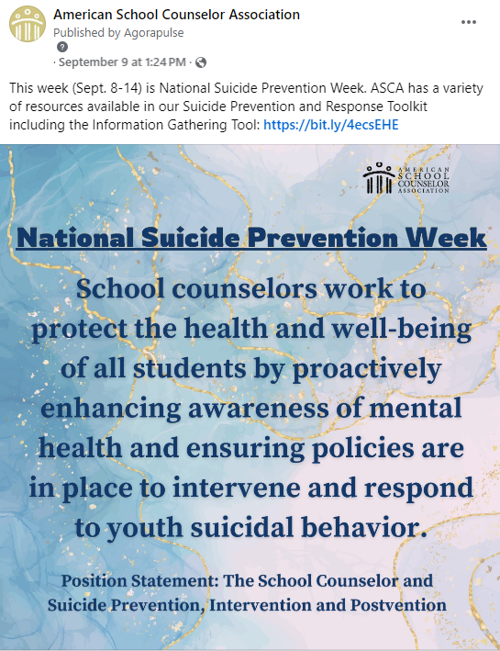

Strategy Guidelines:

* More news focused
* Content examples:
  + Announcements and awards
  + Webinars
  + I Am ASCA
  + Conference registration and sessions
  + Position statement highlights and public comment periods
* Post Frequency:
  + At least three times a week
  + No more than three posts per day

## X (formerly Twitter) & Bluesky

Style Guidelines:

* The least personal of ASCA’s platforms
* Posts should be concise (280-character limit including spaces)
* All posts should have an appropriate hashtag, and try not to use more than 3
* When mentioning a specific person or company, tag them if they have an account.
* Not all posts require a photo, but it is recommended
  + Recommended photo dimensions: 1600x900 px
* Standard X post:

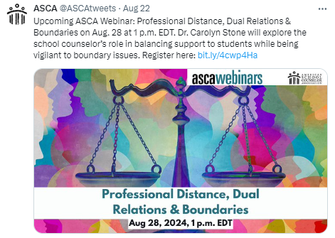

Strategy Guidelines:

* X offers a snapshot of all the information that ASCA posts
* Avoid posting member highlights or potential controversial topics (i.e., LGBTQ+) to avoid trolls
* It has the least amount of storytelling of all platforms
* Content Examples:
  + Announcements and awards
  + Webinars
  + Conference registration and sessions
  + Resources shared from other organizations
* Post Frequency:
  + Cap at five original posts per day

## Instagram

Style Guidelines:

* All posts must have a photo or video
* All captions should be concise: 1-2 sentences
* Best place to use emojis
* All videos should be posted as a Reel
* Standard Instagram Post:

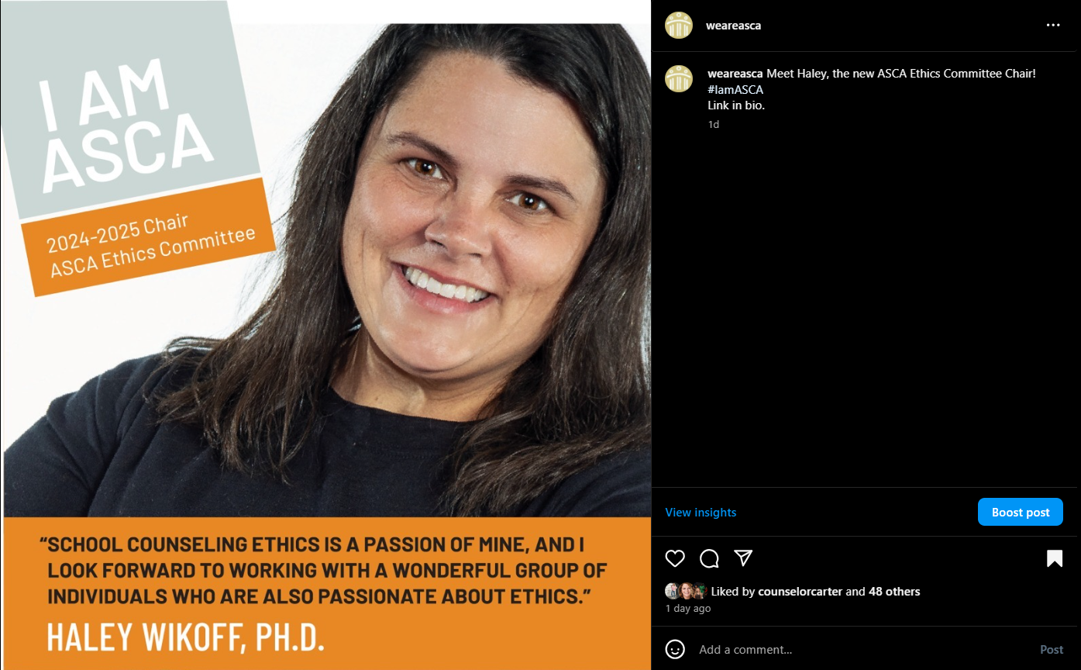

Strategy Guidelines:

* Have eye-catching images
* Avoid having too much text in the image
* Showcase members to give a personal feeling
* Create interactive Stories when possible
* Stories that are related to a specific campaign or hashtag should be placed in a highlight
  + - Ex: #ASCA23 highlight for all ASCA23 related stories
* Post frequency:
  + At least 3 times a week
  + No more than 3 per day
* Story frequency:
  + No more than 10 per day

## LinkedIn

Style Guidelines:

* All captions should be concise; approximately 1-2 sentences
* All posts should have a photo or article
* 2 - 3 hashtags can be used
* Standard LinkedIn Post: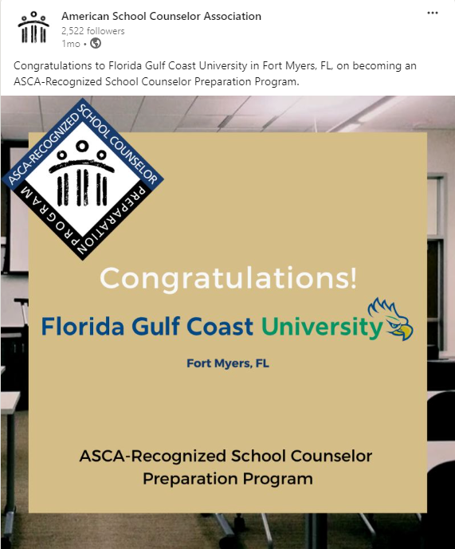

Strategy Guidelines:

* Industry & Company focused
  + The majority of the posts should answer one of these questions:
    - What is going on in the industry?
    - What is ASCA doing for the industry?
    - Who is ASCA as a company?
* Overlap of content is acceptable; the presentation should be different
  + Headlines of posts with similar content should be different and fit with that platform’s focus
  + Vary the articles and photos used
* More professional, less personal