Purpose
This plan provides details of small-group sessions that enhance life-readiness skills and academic success and defines:
- What will be delivered in group sessions
- To whom it will be delivered
- How it will be delivered
- How student attainment of the session’s learning objectives will be assessed in small-group activities

Implementation Notes
- Sessions are delivered to students with identified needs.
- There is a minimum of four sessions with three-12 students.
- Sessions are based on data that identifies student needs.
- Each session is connected to behavior standards from the ASCA Student Standards.
- Directions are in red text below.

School Name | Washington Park High School
School Counselor Name | Gabriel Santiago and Lena Stittmeyer | School Year | 2025–2026
Small Group Title or Focus | New Student Support Group
Number of Sessions | Six
Reason for this group:  How will this group  help students  improve achievement and/or contributing factors? | We have found new students often earn lower grades when transitioning to our school mid-year. This group is designed to help new students successfully transition and maintain a strong GPA. In the previous school year, the overall GPA of 63% of students who enrolled mid-year dropped one or more points.

Nine students in grades 10–12 have enrolled at WPHS between Oct. 1 and Nov. 1. In their previous schools, the GPAs of these nine students ranged from 2.5–4.0, with an average of 3.4. Five of the new students had a GPA of 3.0 or higher, and four had lower than a 3.0.

Attendance Data (Use “NA” if no data applies.)
Attendance data for these nine students did not indicate excessive absences.
Discipline Data (Use “NA” if no data applies.)
Data for these nine students did not indicate discipline issues.
Other Data (Use “NA” if no data applies.)
EXAMPLE
ASCA National Model® Fifth Edition 1 8/25
Add or remove sessions as needed.
Session | Behavior Standard  from the  ASCA Student Standards |  | Learning Objective | Pre-/Post-Assessment Statements
 | Identify one behavior standard per session. A standard may be repeated in multiple sessions. |  | - Limit of one objective aligned with the selected standard per session.  - Learning objective may be used more than once.  - Begin each example with “Students will…” | - Write one-two assessment items aligned with each learning objective.  - Administer pre-assessment for entire small group before or during session one.
1 | B# | Ability to manage transitions and ability to adapt to changing situations and responsibilities | Students will adapt to change. | 1. What skills are needed to adapt to change?
 | SMS 10. |  |  | 2.
2 | B# | Positive relationships with adults to support success | Students will identify three adults they can go to for help at school. | 1. I can name three adults I can go to for help at WPHS.
 | SS .3 |  |  | 2.
3 | B# | Engagement in challenging coursework | Students will articulate specific behaviors associated with effective class participation, as defined by the course instructor. | 1. I pay attention and take notes in class.
 | LS 8. |  |  | 2.
4 | B# | Ability to manage transitions and ability to adapt to changing situations and responsibilities | Students will identify and explain phases of transition (endings/letting things go, neutral zone, beginnings). | 1. Explain each of the three phases of transition.
 | SMS 10. |  |  | 2.
5 | B# | Leadership and teamwork skills to work effectively in diverse groups | Students will participate in groups/teams in a variety of settings. | 1. What are two school extracurricular activities that match your interests or skills?
 | SS 7. |  |  | 2.
6 | B# | Leadership and teamwork skills to work effectively in diverse groups | Students will define the underlying skills needed to be an effective leader (communication, interpersonal skills, problem-solving, collaboration, etc.). | 1. List at least three skills needed to be an effective leader.
 | SS 7. |  |  | 2.
EXAMPLE
ASCA National Model® Fifth Edition 2 8/25
Minimum
of four sessions
with three–
12 students

- Administer pre-assessment for entire small group before or during session one.
- Record pre-assessment data. Optional Data Organizer on the last page of the plan can be used for this information (Life-Readiness baseline data).
Session 1 Focus:
Describe the teaching content for this session. | This session will focus on naming skills needed to adapt to new situations, including enrolling in a new school.
Describe how students will practice the content. | Change jar discussion – A jar will be filled with slips of paper describing different changes (some big, some small). Each student draws one, shares how they might feel and names a skill they will need to respond to the change. The student will role play the skill with the school counselor.
Session 2 Focus:
Describe the teaching content for this session. | This session will focus on helping students identify adults in the building they can go to for help when they have a need or concern. Names and images of school staff, such as teachers, school counselors, coaches, administrators, media specialist, office staff, support staff, will be shared in the group. Their roles will be discussed.
Describe how students will practice the content. | Students will review names and roles of school staff. They will complete their own individual support triangle. Each corner of the triangle represents one trusted adult.
Session 3 Focus:
Describe the teaching content for this session. | Strategies for effective class participation will be presented. Strategies include  - Sit where you can focus  - Maintain focus on the instructor/speaker  - Limit distractions  - Use active listening  Several note-taking methods will be shared.
Describe how students will practice the content. | Students will discuss strategies to stay present in the classroom. They will conduct an online search for note-taking methods and select one that seems most helpful to them. They will try one of the note-taking methods in at least one class over the next week and report back on its effectiveness to the group in the next session.
EXAMPLE
ASCA National Model® Fifth Edition 3 8/25
Session 4 Focus:
Describe the teaching content for this session. | Three phases of transition will be presented.  - Ending (Letting Go)  - Neutral Zone (In-Between Phase)  - New Beginning
Describe how students will practice the content. | Students will identify which stage they think they are in. Each will participate in an activity based on the stage selected and share with the group.  - Ending Activity: Memory Map  Students draw or write about something they are leaving behind (e.g., a grade level, a routine, a friendship) with the goal of helping them acknowledge what’s changing and expressing their feelings. Prompts include “What will you miss most? What are you proud of from this time?”  - Neutral Zone Activity: Feelings Forecast  Students create a “weather report” for how they feel during uncertain times (e.g., cloudy with a chance of nervousness, sunny with excitement) with a goal to normalize mixed emotions and build emotional vocabulary. Prompt: “What helps you feel calm when things are uncertain?”  - New Beginning Activity: Goal-Setting Stars  Students create a visual or written representation of what they hope for in the new phase (e.g., new school year, new role, new habit) with a goal of encouraging optimism and ownership of the future. Prompt: “What are you excited to try or learn? What strengths will help you succeed?”
Session 5 Focus:
Describe the teaching content for this session. | Students will be asked to create a list of activities they enjoy. A list of all clubs, teams and opportunities will be shared with the group.
Describe how students will practice the content. | Students will match school clubs, teams and opportunities with their list of interests. Students create a timeline of when they will visit or explore two activities at school that are most closely aligned with their interests. If they have difficulty finding activities of interest at school, they will be asked to search online for community or online activities that are appropriate for high school students.
EXAMPLE
ASCA National Model® Fifth Edition 4 8/25
Session 6 Focus:
Describe the teaching content for this session. | Students will be asked to think about themselves as a leader in their new school. They will be asked to consider how they can give support and build community at WPHS through leadership skills. Three leadership skills will be defined, presented and discussed.  - Communication  - Teamwork  - Problem-Solving  - Responsibility  - Growth Mindset
Describe how students will practice the content. | Students will be asked to self-assess their skills in each of the five categories using a four-point Likert scale. They will identify ways they can use their strongest skills to better the school community. To wrap up the group, each student will be given the opportunity to respond to one of these prompts.  - One thing I’ve learned about myself  - A challenge I faced and how I handled it  - Someone who helped me feel welcome  - One thing I’m proud of since starting at this school  - Advice I’d give to a new student

END OF PLAN

EXAMPLE
ASCA National Model® Fifth Edition 5 8/25
Small-Group Data Report

Participation Data Results
Number of students at beginning of plan: |  | 9
Number of students at end of plan: |  | 8
If number of students changes from beginning to ending of plan, provide an explanation for the change. |  | One student returned to her previous school after the third session.
Graphs
If needed, use organizer on the final page to organize the data.
Follow these guidelines for graphs.
Pre-/post-assessment results:
1. Match data reported in the results section.
2. Data represented side by side.
3. Graph aggregate data, not individual student data.

All graphs are bar charts and include:
1. Primary title: ASCA Student Standards Data Results
2. Subtitle with specific details about the students or data represented on graph
3. Y-axis label: describes data being graphed; if Likert scale is used, defines the scale
4. X-axis label: defines what is being compared
5. Data points included for each bar on graph

ASCA Students Standards Data Results
Behaviors Standards Addressed: | - SMS 10. Ability to manage transitions and ability to adapt to changing situations and responsibilities
 | 2. SS 3. Positive relationships with adults to support success
 | - LS 8. Engagement in challenging coursework
 | - SMS 10. Ability to manage transitions and ability to adapt to changing situations and responsibilities
 | - SS 7. Leadership and teamwork skills to work effectively in diverse groups
 | - SS 7. Leadership and teamwork skills to work effectively in diverse groups
EXAMPLE
ASCA National Model® Fifth Edition 6 8/25
Insert graph for data from the ASCA Student Standards pre- and post-assessment results for this plan.

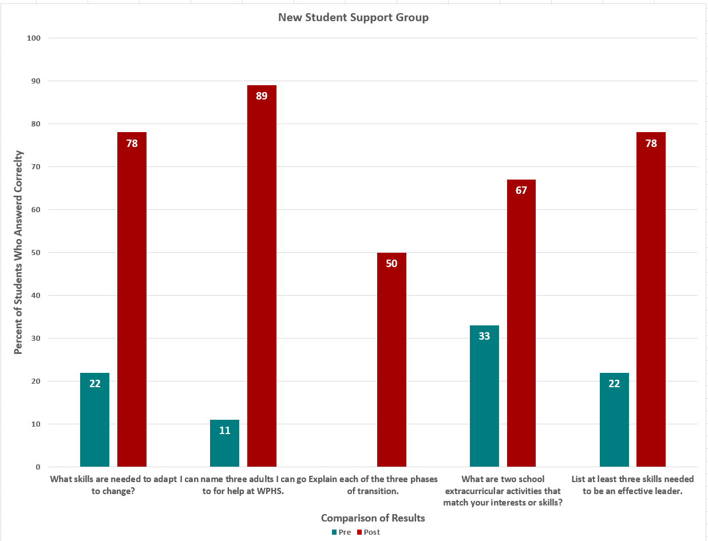

I pay attention and take notes in class.

EXAMPLE
ASCA National Model® Fifth Edition 7 8/25
Follow these guidelines for graphs.
Pre-/post-assessment results:
1. Match data reported in the results section.
2. Data represented side by side.
3. Graph aggregate data, not individual student data.

All graphs are bar charts and include:
1. Primary title: Achievement Data Results
2. Subtitle with specific details about the students or data represented on graph
3. Y-axis label: describes data being graphed
4. X-axis label: defines what is being compared and when data was collected
5. Data points included for each bar on graph

Achievement Data Results
Insert graph for data reported in the baseline and final achievement data results for this plan.
Contributing-Factors Results Graphs (if applicable)
When appropriate, insert graph(s) of baseline and final data such as attendance and discipline
EXAMPLE
ASCA National Model® Fifth Edition 8 8/25
How can you improve your small group?
Consider timing, number and type of strategies, cultural responsiveness, student access and identified barriers.
With the students coming from nine different high schools, it took longer for them to feel comfortable sharing with each other. I realized that I need to give more attention to building group rapport in the first few sessions since the students are working through transition to the new school and becoming comfortable with each other.

How do the results inform future small groups or the school counseling program?
GPAs at the end of the first semester were 3.0 or higher for six of the eight students. Although we cannot show causation for the academic success, students in the group reported that the group experience helped them transition to WPHS and helped them succeed academically. We plan to run a new group in second semester with slight adjustments.

EXAMPLE
ASCA National Model® Fifth Edition 9 8/25

Optional Data Organizer
(Required for RAMP)
 | Baseline Participation Data  Number of students expected to participate in the small group: |  |  | Final Participation Data  Number of students who actually participated in the small group:
 | 9 |  |  | 8 - One student returned to her previous school after the third session
Baseline ASCA Student Standards Data |  |  |  |  | Final ASCA Student Standards Data
Pre-Assessment Data: Calculate the average student response for each Likert-scale item, or percent correct for each knowledge-based item. |  |  |  |  | Post-Assessment Data: Calculate the average student response for each Likert-scale item or percent correct for each knowledge-based item.
ASCA Student Standard Pre-Assessment Results |  |  |  |  | ASCA Student Standard Post-Assessment Results
1. |  |  | 22% |  | 1. |  | 78%
2. |  |  | 11% |  | 2. |  | 89%
3. |  |  | 0 |  | 3. |  | 50%
4. |  |  | 33% |  | 4. |  | 67%
5. |  |  | 22% |  | 5. |  | 78%
6. |  |  | 2.2 |  | 6. |  | 3.8
 |  | Baseline Achievement Data  This data matches baseline achievement data in small group. |  |  |  | Final Achievement Data  Report actual final achievement data (may be different from projected final data)
 |  | Five of nine students had a cumulative GPA of 3.0 or higher at their previous school. |  |  |  | Six of eight students had a cumulative GPA of 3.0 or higher at the end of the first semester.  Note – one student returned to her previous school
 |  |  |  |  |  | Percent Change from Baseline to Final Data:
 |  |  |  |  |  | 20% increase
EXAMPLE
ASCA National Model® Fifth Edition 10 8/25

Baseline Attendance Data  (when applicable) | Final Attendance Data  (when applicable)
Baseline Discipline Data  (when applicable) | Final Discipline Data  (when applicable)

EXAMPLE
BLANK TEMPLATE FOLLOWS EXAMPLE
ASCA National Model® Fifth Edition 11 8/25
School Name
School Counselor Name |  | School Year
Small Group Title or Focus
Number of Sessions
Reason for this group:
How will this group
help students
improve achievement and/or contributing factors?

Attendance Data (Use “NA” if no data applies.)
Discipline Data (Use “NA” if no data applies.)
Other Data (Use “NA” if no data applies.)

Session | Behavior Standard(s)  from the  ASCA Student Standards |  | Learning Objectives | Pre-/Post-Assessment Statements
1 | B# |  | Students will | 1.
 |  |  |  | 2.
2 | B# |  | Students will | 1.
 |  |  |  | 2.
3 | B# |  | Students will | 1.
 |  |  |  | 2.
4 | B# |  | Students will | 1.
 |  |  |  | 2.
5 | B# |  | Students will | 1.
 |  |  |  | 2.
6 | B# |  | Students will | 1.
 |  |  |  | 2.

Session 1 Focus:
Describe the teaching content for this session.
Describe how students will practice the content.
Session 2 Focus:
Describe the teaching content for this session.
Describe how students will practice the content.
Session 3 Focus:
Describe the teaching content for this session.
Describe how students will practice the content.
Session 4 Focus:
Describe the teaching content for this session.
Describe how students will practice the content.
Session 5 Focus:
Describe the teaching content for this session.
Describe how students will practice the content.
Session 6 Focus:
Describe the teaching content for this session.
Describe how students will practice the content.

END OF PLAN

Small-Group Data Report

Participation Data Results
Number of students at beginning of plan:
Number of students at end of plan:
If number of students changes from beginning to ending of plan, provide an explanation for the change.
Graphs
If needed, use organizer on the final page to organize the data.
ASCA Students Standard(s) Data Results
Behavior Standards Addressed:
Insert graph(s) for data from the ASCA Student Standards pre- and post-assessment results for this plan.

Achievement Data Results
Insert graph for data reported in the baseline and final achievement data results for this plan.
Contributing-Factors Results Graphs (if applicable)
When appropriate, insert graph(s) of baseline and final data such as attendance and discipline

How can you improve your small group?
Consider timing, number and type of strategies, cultural responsiveness, student access and identified barriers.
How do the results inform future small groups or the school counseling program?

Optional Data Organizer
(Required for RAMP®)
 | Baseline Participation Data  Number of students expected to participate in the small group: |  |  | Final Participation Data  Number of students who actually participated in the small group:
Baseline ASCA Student Standards Data |  |  |  |  | Final ASCA Student Standards Data
ASCA Student Standards Pre-Assessment Results |  |  |  |  | ASCA Student Standards Post-Assessment Results
 |  | Baseline Achievement Data  This data matches baseline achievement data in small group. |  |  |  | Final Achievement Data  Report actual final achievement data (may be different from projected final data)
 |  |  |  |  |  | Percent Change from Baseline to Final Data:
 |  |  |  |  |  | %

Baseline Attendance Data  (when applicable) | Final Attendance Data  (when applicable)
Baseline Discipline Data  (when applicable) | Final Discipline Data  (when applicable)

